Cleaning and Maintenance Information

Accessories

ATD121L Illuminated Aluminium
Stair Edging

Data Sheet: (sheet 1 of 2) February 2012

This leaflet has been compiled to help the user obtain optimum performance and satisfaction from their selected product:

Preventative Maintenance Programme

A regular scheduled maintenance programme should be employed to prevent the build up of dirt and grease, which will reduce the slip-resistant properties of the channel and detract from the overall appearance of the product.

NB. Under no circumstances should any cleaners containing hydrocarbons, bleach or citrus based agents be used to clean any Gradus Stair Edging.
Steam cleaners, power washers, floor sealants, polishes or any coatings should not under any circumstances be used on inserts.

Daily Cleaning

Brush down the channel using a soft bristled brush and remove dust particles from the insert by wiping with a damp cloth.

Aluminium Channel

Stubborn marks such as boot blacking may be removed from the aluminium channel by means of a green scotch pad and an aluminium safe detergent. Light surface scratches can be removed with careful use of fine wire wool and buffed with a soft cloth. If the channel has been anodised, wire wool should not be used.

Interior standard and Interior grained Inserts
Twice Weekly or as Required

Brush down the channel using a soft bristled brush. With clean, warm water, containing the correct dilution of aluminium safe cleaning solution apply a small amount to a well rung out damp mop or a Vileda Padmaster/3M Doodlebug and gently clean the surface of the insert in a left to right motion. During the clean, the water must be changed on a regular basis. Do not soak the insert. Once the stair edging has been cleaned thoroughly rinse with fresh, clean water, making sure as much water is removed as possible.

On completion the staircase should not be used until completely dry.
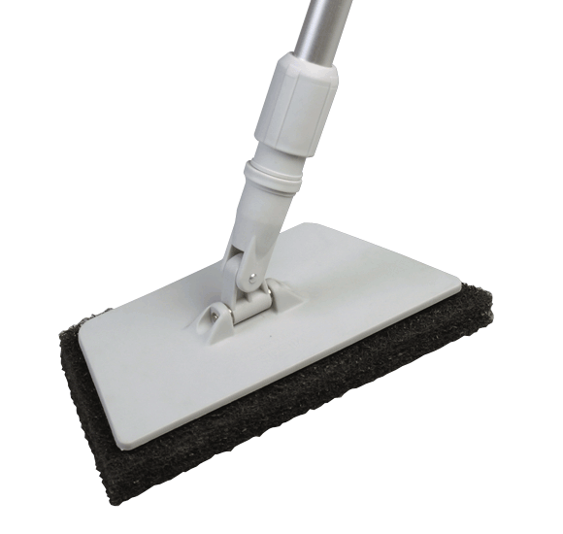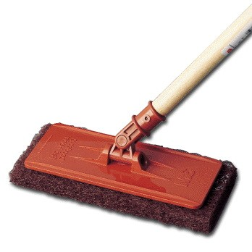

Xtra-grip and Xtra-grip Plus Inserts
Twice Weekly or as Required

Brush down the channel using a soft bristled brush. With clean, warm water, containing the correct dilution of aluminium safe cleaning solution apply a small amount to a well rung out damp mop or a Vileda Padmaster/3M Doodlebug and gently clean the surface of the insert in a left to right motion. During the clean, the water must be changed on a regular basis. Do not soak the insert. Once the stair edging has been cleaned thoroughly rinse with fresh, clean water, making sure as much water is removed as possible

For heavily soiled inserts use a heavy duty aluminium safe alkaline cleaner and scrub the area with a green scouring pad in a left to right motion. During the clean, the water must be changed on a regular basis. Do not soak the insert. Once the stair edging has been cleaned thoroughly rinse with fresh, clean water, making sure as much water is removed as possible

On completion the staircase should not be used until completely dry.


Gradus Accessories, Park Green, Macclesfield, Cheshire SK11 7LZ England UK Tel: 01625 428922 Fax: 01625 433949
www.gradusworld.com

Vileda Padmaster
3M Doodlebug

ATD121L Illuminated Aluminium
Stair Edging
Data Sheet: (sheet 2 of 2) February 2012
Cleaning and Maintenance Information
Gradus Accessories, Park Green, Macclesfield, Cheshire SK11 7LZ England UK Tel: 01625 428922 Fax: 01625 433949
www.gradusworld.com

Accessories
Visual Inspection - Monthly

Check the stair edging for physical damage and for any exposed LED strips or cables. Check lighting system in stair edgings for faulty LEDs (normally indicated by uneven spacing).

Full System Test - Annually

A full system test should be conducted by a competent service engineer/electrician.

Note: a visual inspection may be carried out by responsible personnel but it is recommended that actual maintenance should be carried out by suitably qualified personnel (qualified electrician).

Recommended Cleaning Products for ATD121L

Gradus has worked with Selden Research to undertake extensive testing on all Gradus stair edgings. As a result, a range of cleaning products has been recommended for use with Gradus stair edgings in a variety of environments.

The cleaning products listed below are suitable for this particular stair edging.

For further information about these cleaning products, including environment suitability, instructions for use and COSHH data sheets, please contact:
Selden Research Limited, Staden Business Park, Staden Lane, Buxton, Derbyshire, SK17 9RZ.
Tel: 01298 26226
Email: gradus@selden.co.uk
Web: www.selden.co.uk

Product Description | Name of Cleaner | Code | Vinyl Floor Safe
Neutral Cleaners | Neutral Scrubber Drier Detergent | F176 | Yes
Neutral Cleaners | Sabre | C054 | Yes
General Purpose Cleaners | Multi Purpose Cleaner | F010 | Yes
General Purpose Bactericidal Cleaners | Selgiene | C020 | Yes
General Purpose Bactericidal Cleaners | Selgiene Ultra | C066 | Yes
Heavy Duty Alkaline Cleaners | H.D. Degreaser | F052 | Yes
Heavy Duty Alkaline Cleaners | Selclen S | F014 | Yes

